PROCESSING MECHANISM / FLOW

SCENARIO ONE (1): First Bills Pay & First Chekout
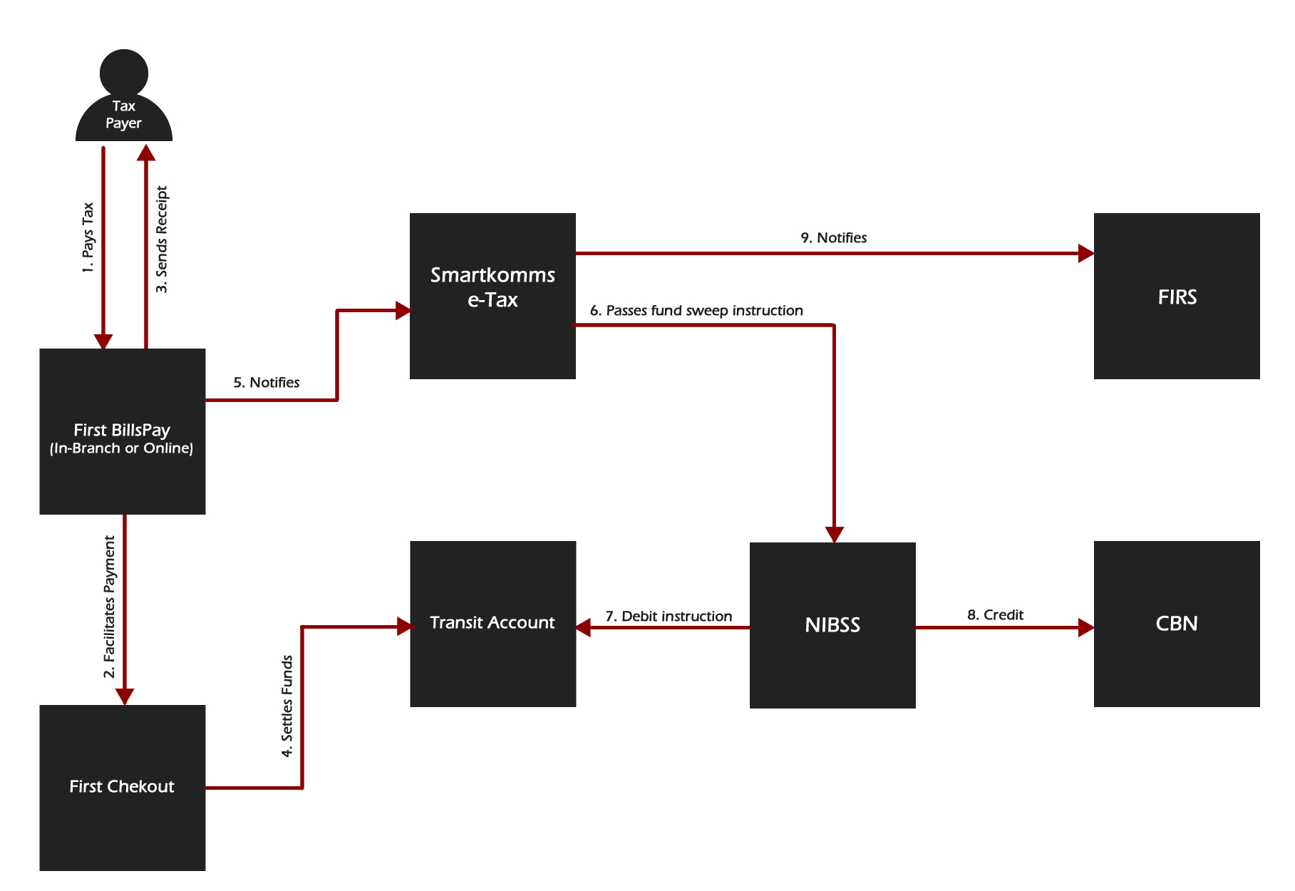

- Tax payer goes to First Bills Pay online or walks into a branch for tax payment where a teller makes use of First Bills Pay In-Branch to process the tax payment.
- First Chekout is used to facilitate the payment.
- Once payment is successful, First Bills Pay would generate a receipt for the payer.
- First Chekout settles the funds collected into the transit account.
- First Bills Pay sends a notification to Smartkomms e-tax system via an API.
- Smartkomms e-tax system aggregates the amount collected on a daily basis and passes a fund sweep request to NIBSS for the total sum collected for the previous day.
- NIBSS passes a debit instruction for the transit account to the bank.
- NIBSS credits FIRS’ account in CBN.
- Smartkomms e-tax notifies the system of FIRS of the transaction.
SCENARIO TWO (2): BAMS & PayChoice
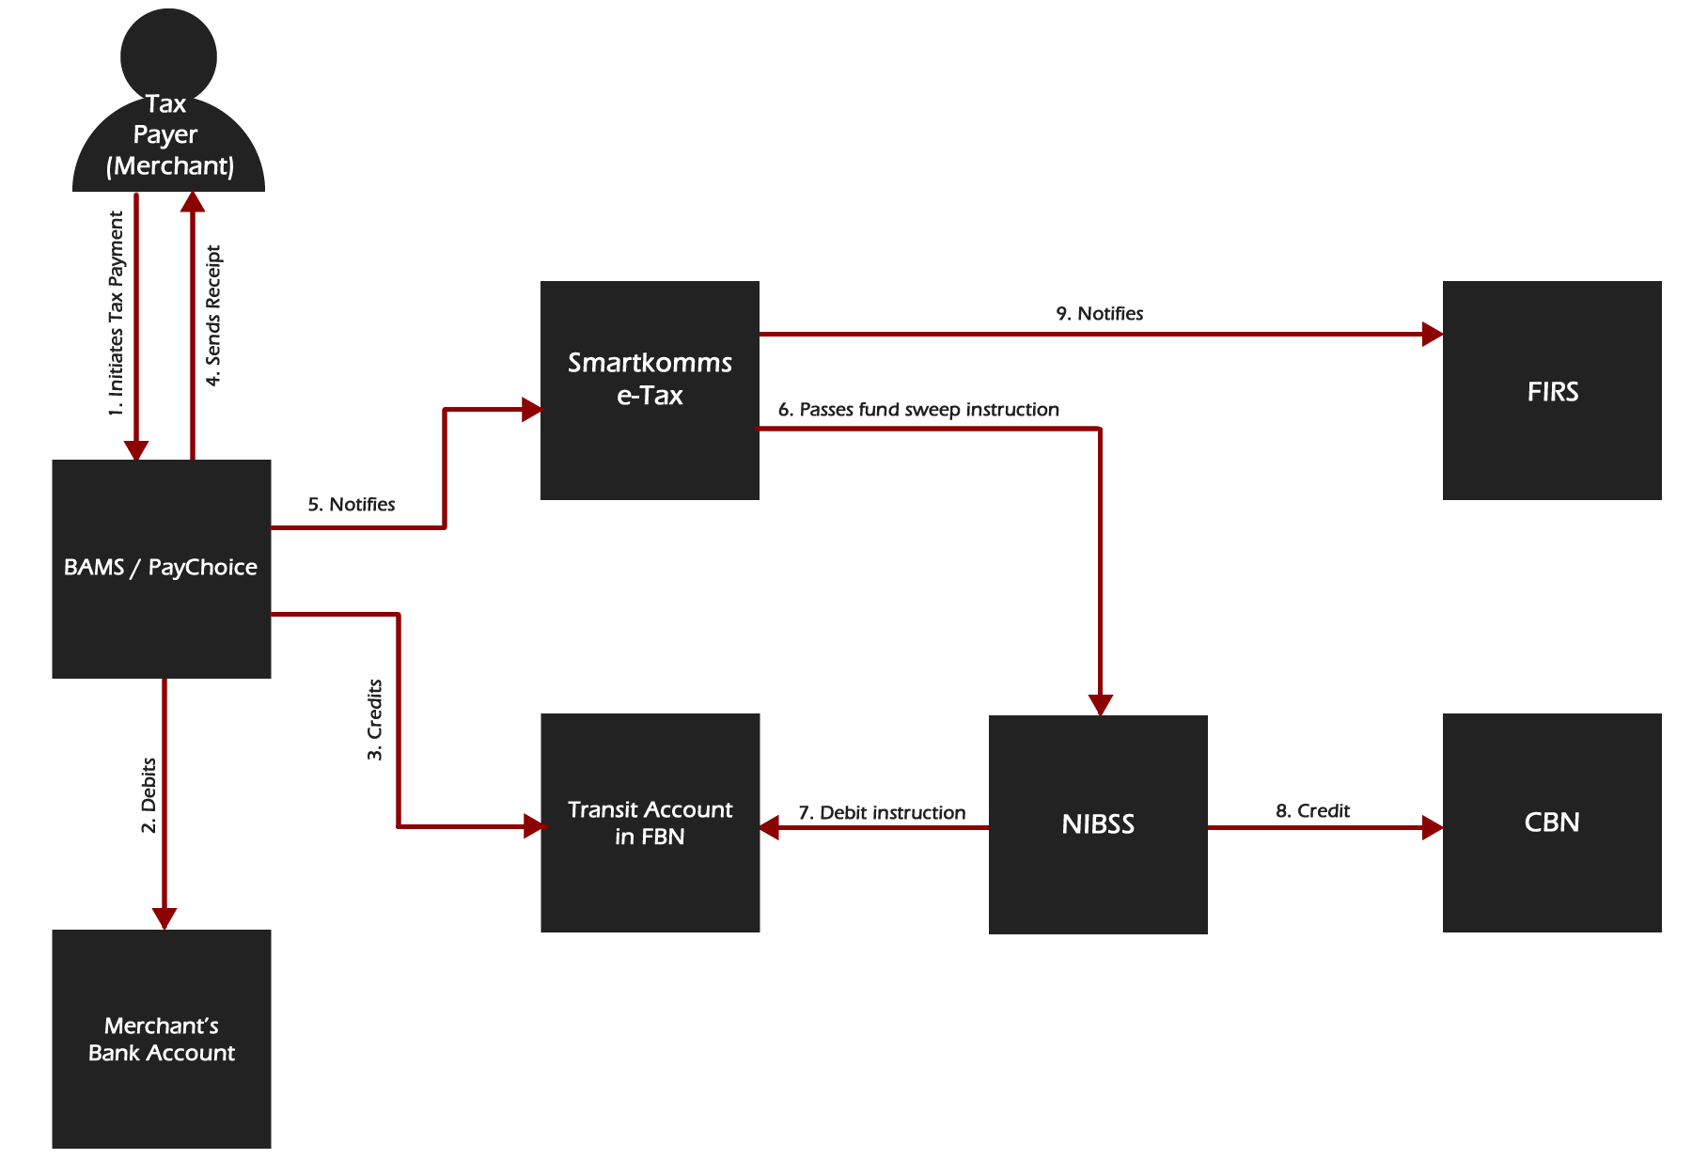
- Tax payer (merchant) initiates tax payment on BAMS / PayChoice.
- BAMS / PayChoice debits the merchant’s account.
- BAMS / PayChoice credits the transit account in FBN.
- BAMS / PayChoice generates receipt for the tax payer.
- BAMS / PayChoice notifies Smartkomms e-tax.
- Smartkomms e-tax system aggregates the amount collected on a daily basis and passes a fund sweep request to NIBSS for the total sum collected for the previous day.
- NIBSS passes a debit instruction for the transit account to the bank.
- NIBSS credits FIRS’ account in CBN.
- Smartkomms e-tax notifies the system of FIRS of the transaction.

